Roofs

It is inevitable that a roof will require repair or a complete replacement depending on its age and maintenance record. Whether a roof requires urgent attention or is reaching the end of its lifetime, the following questions should be asked when preparing to repair or replace a roof:

- Is the roof original to the building, or has it been replaced before? (Historical photographs, if available, may help answer this question.)
- What is the root cause of the roofing problem? Is it the failure of surface materials such as shingles or the failure of related materials such as gutters and downspouts, sheathing, or flashing?
- Depending on the cause of failure, is it feasible to repair the roof?
- If replacement is essential, is the historic roofing material still available today? Can it be custom designed?
- Is there is a specialized roofing contractor, familiar with the material, available to install the roof? Will the contractors be closely supervised during the installation?
- If the historic roofing material is no longer available or restricted by building codes, is there an alternative material available that matches closely in scale, texture, and color?

The photos below show examples of recommended and not recommended repair and replacement roof options:

Recommended: Retaining and repairing durable and character-defining historic roofing materials in good condition.

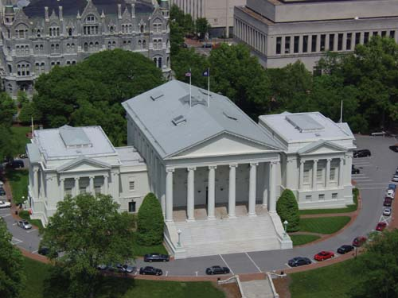

Not recommended: Replacing durable and character-defining historic roofing materials in good condition with a roofing material perceived as more sustainable.

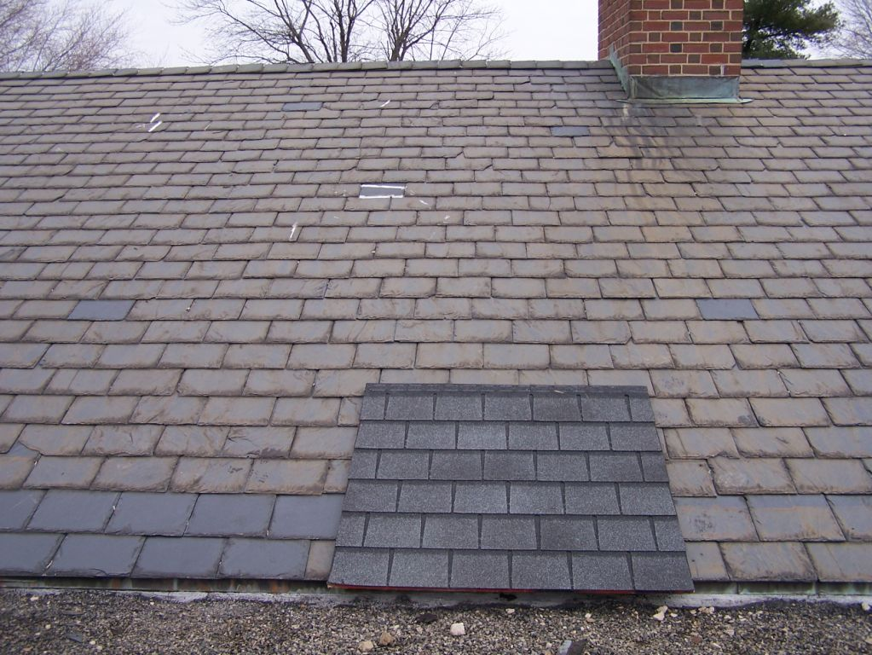

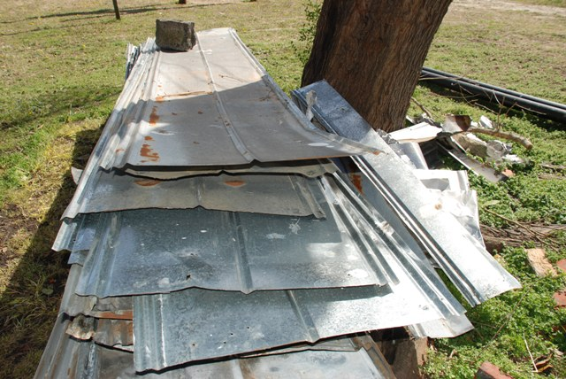

The recommendations above are taken from the Illustrated Guidelines from the Illustrated Guidelines on Sustainability for Rehabilitating Historic Buildings, NPS, April 2011. The photo examples are from state-owned properties throughout Virginia.

