Windows

Historic preservation doesn’t have to be a roadblock to achieving energy efficiency. To balance preservation and sustainability, keep in mind the following questions:
- Are the windows severely deteriorated beyond all reasonable repair efforts? Is the glazing missing? Are the sashes crumbling or corroding?
- Is the window still structurally sound where it can be removed, refinished, possibly re-glazed, and reinstalled?
- Will exterior or interior storm windows work instead of replacement?
- If the window is missing or severely deteriorated, is a manufacturer available to re-create the window “in-kind” to look just as it used to?
- If the window material is unavailable anymore, what is the next closest option that will create a window that looks virtually similar?
- If a new window with new material is used, what is the life expectancy? Will the new window require replacement in 5, 10, 20, or 40 years?
Rarely factored into a cost analysis of retention and repair versus replacement is the cost to the environment. There are energy costs associated with manufacturing and transporting the new materials as well as the issue of waste when the existing windows are disposed.

The photos below show examples of recommended and not recommended repair and replacement window options:

Recommended: Repairing the existing windows “in-kind;” or if existing windows are too deteriorated to repair installing compatible and energy-efficient replacement windows that match appearance, size, design, proportion, and profile of existing historic windows and that are durable (no vinyl), repairable, and recyclable.

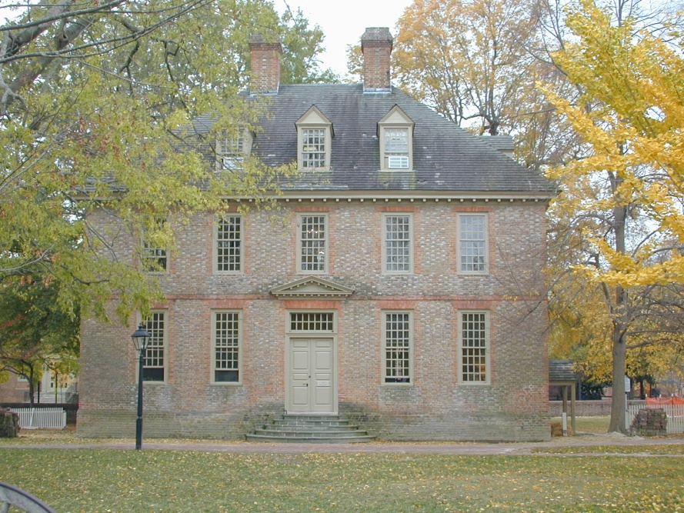
Original windows were removed, repaired, and reinstalled.

Not recommended: Completely removing and installing incompatible or inefficient replacement windows units that are not durable, recyclable, or repairable when existing windows are deteriorated beyond repair or missing.

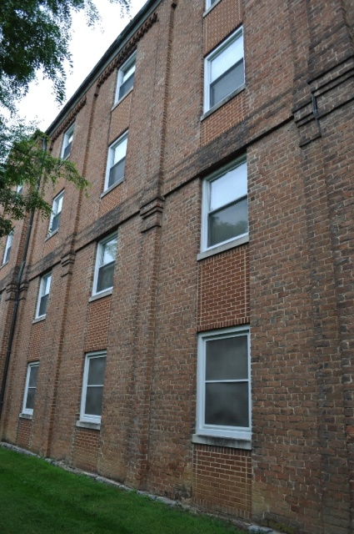
Inappropriate double-hung, replacement window.
Inappropriate brick fill to downsize windows.

Recommended: Retaining and repairing durable historic materials, including windows.

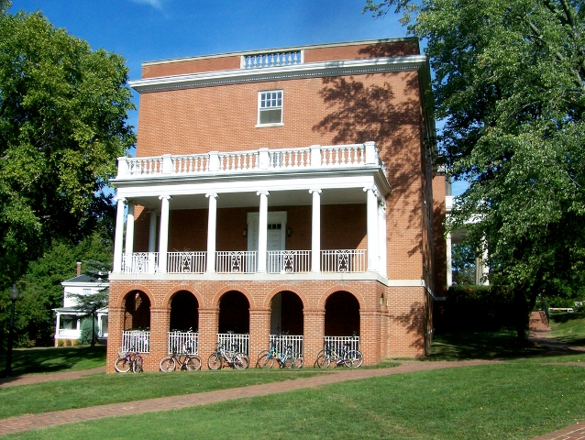

Not recommended: Removing durable historic materials, including windows, and replacing them with materials perceived as more sustainable; e.g. replacing repairable windows with new windows for perceived energy performance.

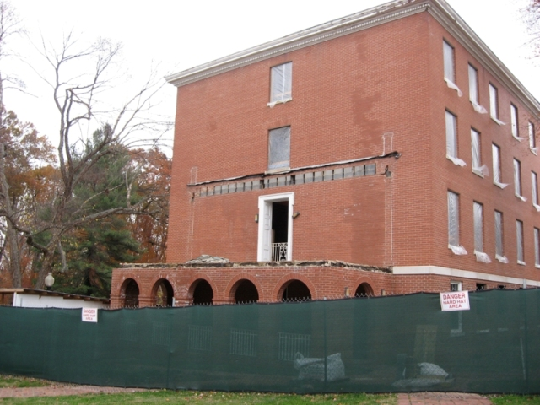

The recommendations above are taken from the Illustrated Guidelines from the Illustrated Guidelines on Sustainability for Rehabilitating Historic Buildings, NPS, April 2011. The photo examples are from state-owned properties throughout Virginia.

