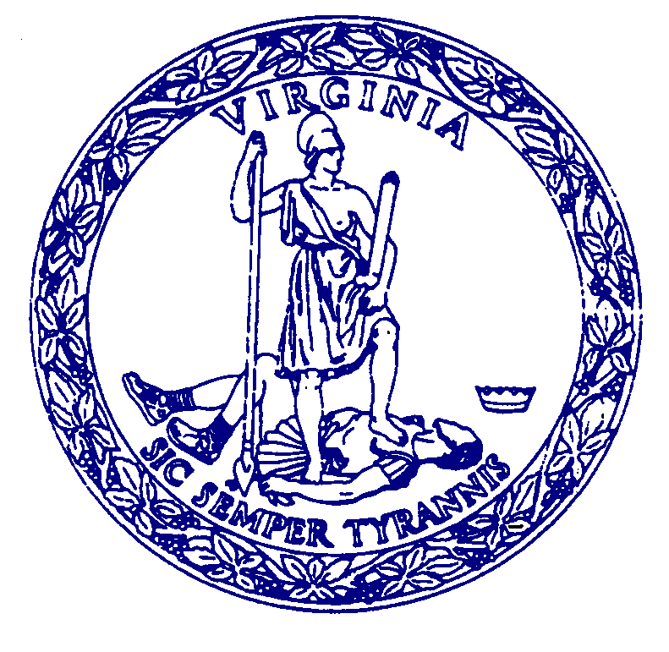
AGENDA

MEETING

COMMISSION FOR HISTORICAL STATUES IN THE UNITED STATES CAPITOL

July 1, 2020 @ 5:30 p.m.

This meeting will take place online and can be accessed as follows:

Join with Google Meet: meet.google.com/bsa-tzyn-zjn

Join by phone: (US) +1 216-930-8978‬ PIN: 920 944 614‬#‬‬

Call to Order…………………………………………………Julie Langan, Ex-Officio Member

Roll Call Attendance

Opening Remarks……………………………………………Ralph S. Northam, Governor

Election of Citizen Commission Members

Adjourn

