  - VIRGINIA DEPARTMENT OF HISTORIC RESOURCES

EASEMENT PROGRAM

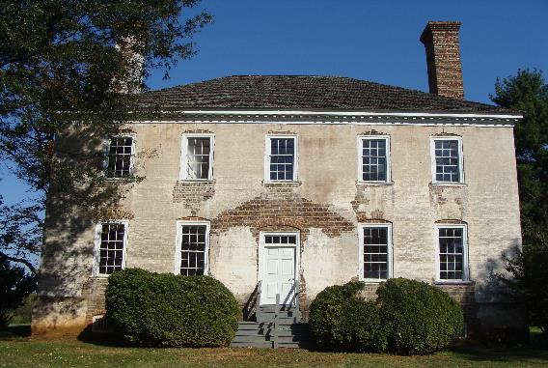
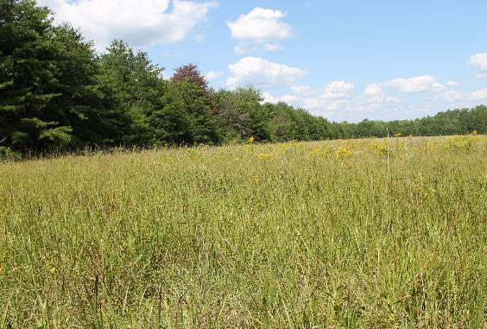
https://www.dhr.virginia.gov/easements

Virginia’s Easement Program  This brochure contains information about the Historic Preservation Easement Program administered by the Virginia Department of Historic Resources (“VDHR”) and describes the process for conveying an easement to the Virginia Board of Historic Resources (“Board” or “VBHR”). | historic dwellings • Battlefields • Archaeological sites • open-space land • mills • barns • landscapes • theaters • courthouses | What is the role of the easement holder?  The Board is authorized to acquire and hold historic preservation and open-space easements and the VDHR is the agency charged with administering the easements on behalf of the Board. Easements held by the Board are administered by Easement Program staff at the VDHR. (Virginia Code § 10.1-2204)
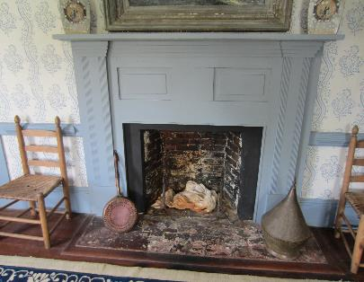 | “The mission of the easement program is to ensure the preservation—in perpetuity—of the historic landmarks that immeasurably enhance the quality of our lives and the character of our Commonwealth.”
What is an  Historic Preservation Easement?  Preservation easements are conservation easements that protect properties with historic, architectural, and archaeological significance, and can also be used to preserve open-space and natural resource values. A conservation easement is a recorded legal agreement between a landowner and a government agency or land trust that perpetually protects the conservation values of a property, through limits and restrictions on future development and use of the land.  Additional information and materials about administration of the Easement Program may be found at the web link below:  https://www.dhr.virginia.gov/easements | 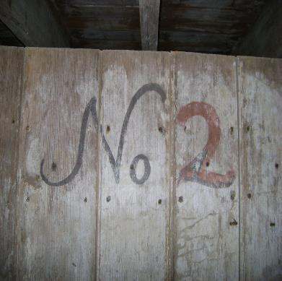

Virginia’s Historic Preservation Easement Program  Virginia’s historic resources are tangible reminders of the state’s rich history and traditions. Through the Easement Program, historically significant buildings, structures, and sites are protected from destruction or inappropriate change, thus ensuring that they will continue to enrich and enlighten future generations of Virginians. The Virginia General Assembly passed legislation establishing Virginia’s Easement Program in 1966, the same year Congress passed the National Historic Preservation Act. The Board accepted its first easement in 1969. Today Virginia’s program is one of the largest in country and is viewed as a model nationwide. The program is designed to protect historic properties that are listed in the Virginia Landmarks Register, Virginia battlefields associated with the Civil War, Revolutionary War, or War of 1812, and other properties of historic significance. | The Virginia Board of Historic Resources administers more than 670 easementS on 43,000 acres of land throughout the commonwealth.

What properties are eligible for the VDHR easement program?
All easements conveyed to the Virginia Board of Historic Resources must meet one of the following criteria:
- Property is individually listed in the Virginia Landmarks Register (VLR).
- Property is a contributing resource within a VLR-listed historic district.
- Property is a Virginia battlefield or site identified with a priority rating in one of the following reports issued by the National Park Service's American Battlefield Protection Program:
  - “Report on the Nation's Civil War Battlefields (1993),” available at the following web link: https://irma.nps.gov/DataStore/Reference/Profile/2274482), or
  - “Report to Congress on the Historic Preservation of Revolutionary War and War of 1812 Sites in the United States (2007),” available at the following web link: https://irma.nps.gov/DataStore/Reference/Profile/2274495.
- Other property of historic significance as determined by VDHR.

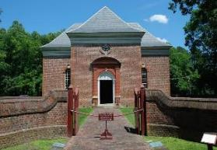
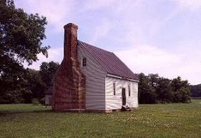
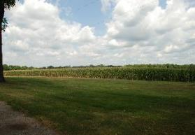

TYPICAL easement provisions and RESTRICTIONS:
The list below is not intended to be comprehensive and is provided for informational purposes only

√ Historic buildings and structures must be maintained in their existing condition or better; prohibits willful demolition or demolition by neglect

√ Requires review and approval of alterations to the exterior of historic buildings and structures

√ Historically significant interior features and spaces shall not be altered or removed without prior written approval

√ Requires review of alterations to historic landscape and setting

√ Requires review of all new construction to protect historic setting & character
√ Physical public access required a minimum of two days per calendar year, subject to reasonable restrictions
√ Restricts certain activities and uses

√ Requires review of ground disturbing activities to protect archaeological sites or features

√ Requires professional archaeological survey for specific ground disturbing activities

√ Prohibits relic hunting

√ Prohibits or limits subdivision and new construction

√ Prohibits mining /extraction of mineral resources
√ Forest Management and Riparian Buffer provisions (as applicable)

√ Regular monitoring and inspection of the property by VDHR Easement Program staff to assess current conditions relative to individual easement terms and provision

tax benefits highlights:
  - Federal income tax deduction: Donations of historic preservation/open-space easements that meet federal tax code requirements may entitle the donor to a federal income tax deduction. For tax year 2021 and after, the deduction is limited to 50% of adjusted gross income, which may be carried forward for an additional 15 years or until the donation is fully expended, whichever comes first.
  - Virginia state income tax credit: donations of historic preservation/open-space easements that meet virginia tax code requirements may entitle the donor to a tax credit equal to 40% of the value of the easement. The amount of the credit used by a taxpayer may not exceed $20,000 for taxable year 2021. Any unused portion may be carried forward a maximum of 13 consecutive taxable years following the taxable year in which the credit was initiated or transferred to another Virginia taxpayer.
Reduction in Federal Charitable Deduction: Treasury Regulations, effective August 28, 2018, reduce the federal charitable deductions for gifts of qualifying open-space or conservation easements by the amount of the land preservation tax credit (40% of the easement value). For example, if a landowner donates an open-space easement with a value of $500,000, the state tax credit would be $200,000 and the federal deduction would be reduced from $500,000 to $300,000.
**VDHR provides this information about tax benefits to assist landowners, but not as tax advice. Please consult your attorney or tax advisor about qualifying for tax benefits associated with a gift of conservation easement.

FEES
VDHR will charge the following fees associated with submitting an easement application form and conveyance of an
easement to the Virginia Board of Historic Resources. Some of these fees may include:
Fee | Amount | Due
Easement Application Fee | $500 | With application
Grant Funded Easements (other than Commonwealth of VA) | $10,000 | When BDR site visit is scheduled
Reconsideration of Easement Offer | $1,000 | With application
Update or Revision of Baseline Documentation | $1,500 | Prior to DHR conducting work
Amendment of Existing Easement | $2,000 | With application

A $500.00 Application Fee must be provided in accordance with the instructions on the Billing Statement at the same time the Easement Application Form is submitted. This fee will go toward VDHR’s due diligence review and analysis of the proposed offer. VDHR is unable to accept credit cards or other electronic payments. Applications will not be reviewed until the application fee has been received by DHR.
Once the easement is recorded, additional fees may be applicable. Easement Program Policy #12: Administrative Fees contains a schedule of these fees as well as additional information about VDHR’s administrative fee policy.

REQUIREMENTS
For a full list of requirements, please see VDHR’s Easement Application Form and Instructions.
- Title Commitment & Title Insurance Policy: the applicant must obtain a title insurance policy insuring the Commonwealth of Virginia, Board of Historic Resources that includes the following:
  - Continuous chain of title of ownership interests for the property (with copies of all relevant documents) dating back to at least 1940 must be submitted with the easement application.
  - Title commitment prepared by a Virginia licensed title searcher, title company, or attorney.
- Must include legible copies of all deeds and plats in the chain of title ownership and all encumbrances identified as exceptions in the commitment.
VDHR’s Easement Title Commitment Policy Requirements document contains additional information. The donor/applicant is responsible for obtaining the title insurance policy and any associated settlement costs.
- Boundary Survey: a current (within one year) boundary survey prepared by a Virginia licensed surveyor is required for all easement projects. If a current survey is not available when the easement application is submitted,
a preliminary draft survey should be provided to VDHR for review as soon as possible.
- Proof of Insurance: general liability insurance policy and homeowners policy (as applicable) is required. At the time of easement recordation, the Board, VDHR, and the Commonwealth of Virginia must be added as additional insureds.
- Leases: copies of all residential, agricultural, commercial or other leases that will be in effect at the time of easement recordation. Any unrecorded lease must include subordination language provided by or approved in advance by VDHR. Existing leases may need to be amended to include the appropriate subordination language.
- Mortgage or Other Lien: for any mortgage/lien that will be in effect at the time of easement recordation, the following must be provided: (i) written documentation from lender(s) indicating their willingness to subordinate the lien to the easement; (ii) name and position of individual signing on behalf of the lender(s); (iii) document identifying that individual as authorized to sign on behalf of the lender(s); (iv) name of Trustee(s) who will be signing on behalf of the lender(s); and (iv) recorded Appointment of Substitute Trustee document (as applicable).
- Organizational & Authorization Documents: required if property is owned by an LLC or other corporate entity.
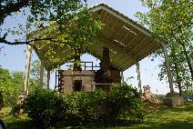 | STEPS TO CONVEYING AN EASEMENT TO THE BOARD OF HISTORIC RESOURCES
The following outline describes the basic steps for conveying an easement to the Virginia Board of Historic Resources and is intended to be a summary overview. Please note that the timeline for donation of an easement may vary, but plan for a minimum of 12-18 months depending on the complexity of the project and applicable grant funding sources.
- PLANNING AND GATHERING INFORMATION: Owner contacts VDHR Easement Program staff to request information and discuss the Easement Program and donation process. Staff conducts research to confirm the historic significance of the property and its eligibility for the Easement Program as well as identify associated conservation values. Staff provides owner an Easement Information Packet, the Easement Program Policies, and Easement Application Form. To determine whether an easement is a good fit for you and your property, VDHR recommends that owners consult with an attorney who has experience with conservation easements.
- PRELIMINARY SITE VISIT (OPTIONAL): At staff discretion, a preliminary site visit may be made to discuss the program with a potential donor, review the standard easement template, and tour the property.
- EASEMENT APPLICATION FORM: Owner or designated representative submits completed, signed, and dated Easement Application Form and $500.00 Application Fee at least thirty (30) calendar days prior to Easement Acceptance Committee meeting. Staff processes application and reviews all title documents and deeds, plat of boundary survey, leases, licenses or other rights held by third parties to access or use the property being offered for easement, copies of all liens and encumbrances, grant agreements and any associated review required pursuant to Section 106 of the National Historic Preservation Act, environmental site assessment (if applicable), and state and local planning documents to identify supporting policies and potential conflicts.
- EASEMENT ACCEPTANCE COMMITTEE REVIEW: Upon receipt of a completed Easement Application Form and application fee, staff will notify the owner and the easement offer will be placed on the next meeting agenda of the Easement Acceptance Committee (“EAC” or “Committee”). The Committee will review easement applications in a two-step process. A complete easement application will be presented to the EAC at the first meeting, during which the EAC will consider whether the property meets the threshold requirements for participation in the easement program as well as the historic significance and integrity of the property and its character defining architectural, archeological features and/or setting and landscape features. The Committee will also determine what additional information is required to fully evaluate the proposed easement; and what issues must be addressed in order to make a formal recommendation to the Board concerning acceptance of the easement. Following this first review by the EAC, Easement Program staff will advise the applicant of any determination made by the EAC.

The EAC may take one or more of the following actions:

Recommend approval of the easement offer as proposed;

Recommend that any approval be conditioned on specific requirements or actions;

Not recommend acceptance of the easement offer as proposed; or

Defer making a recommendation where insufficient information is provided or where conditions affecting the property require prior resolution.
Pending receipt of additional information and resolution of all identified issues, the EAC will again consider the proposed easement at a second meeting, at which the EAC may make a formal recommendation concerning acceptance to the Board. Staff will again inform the applicant/owner of the Committee’s recommendation. Written correspondence to owner includes summary of proposed easement provisions and any conditions for approval recommended by the EAC. VDHR’s goal is to resolve issues early in the easement application process and present a final easement proposal to the Board with no conditions attached to approval. If a comprehensive application is received and the project presents no potential issues to be resolved, it is possible that the EAC may make a recommendation during the first meeting.
- VIRGINIA BOARD OF HISTORIC RESOURCES REVIEW: Per evaluation and recommendation from the EAC, the easement offer is added to the agenda for the next quarterly Board meeting. Easement Program staff will notify the property owner of the meeting date and location and will provide information regarding the agenda. At the public Board meeting, Easement Program staff will present the offer, describe the property’s historic significance and the formal documentation of that significance, highlight any special features of the property, specify any reserved rights, and address the EAC’s recommendations, including any recommended conditions of approval. The Board may take the following actions, including, but not limited to: (i) approve the easement offer as proposed; (ii) approve the easement offer with conditions requiring specific requirements or actions; (iii) decline acceptance of the easement offer as proposed; or (iii) defer making a recommendation where insufficient information has been provided by the property owner or his/her designated agent, or where conditions affecting the property require prior resolution. Staff informs the owner of the Board’s decision. Written correspondence sent to the owner documents approval by the Board of an easement offer, including any conditions for the approval, as well as a sunset clause, or a timeframe within which the easement must be recorded.

Per Easement Program Policy #2: Criteria for Acceptance of Easements standard approvals issued by the Board of Historic Resources are valid for two calendar years from the date of the Board’s approval. Each approval of an easement offer by the Board will contain this sunset clause, or timeframe within which the easement must be recorded or the Board’s approval reauthorized. Reconsideration of the offer will be subject to a $1,500 fee.
- DRAFTING EASEMENT DEED: After Board approval, the draft deed of easement is prepared by Easement Program staff based on VDHR’s current standard template, proposed reserved rights, grant funding requirements (if applicable), and any conditions for approval imposed by the Board. Once the document is reviewed internally, the draft easement is given to the owner(s) and his/her attorney. The owner(s) provides VDHR with comments and modifications on the draft deed of easement. After resolving any questions with the owner(s), the revised draft deed of easement and title work are reviewed by the grant funding organization (if applicable) and VDHR’s counsel at the Office of the Attorney General.
- BASELINE DOCUMENTATION REPORT & SITE VISIT: The Baseline Documentation Report describes the characteristics and conditions of the property at the time of easement recordation as well as the features and conservation values that are the subject of the easement. Staff will schedule a site visit to the property within six months of easement recordation to obtain baseline documentation. Documentation will incorporate comprehensive photographic coverage of property, including historically significant interiors. The draft report is sent to the owner for review and the owner provides VDHR with comments and modifications. Staff then prepares final report for signature. As Grantor, the owner(s) must sign the acknowledgment page indicating agreement that the baseline documentation accurately depicts the appearance and condition of the property prior to or at the time of recordation of the easement.
- EASEMENT RECORDATION: Once the final easement draft is approved by the owner, owner’s attorney, grant funding organization (if applicable), Office of the Attorney General, and Easement Program staff, the final draft is signed and notarized in counterpart by the owner(s) and VDHR on behalf of the Board. The owner(s) obtains subordination for any mortgages, leases, or other liens. If applicable, an Appraisal Summary is provided to VDHR 30 days in advance in recordation and completed IRS Form 8283 provided to VDHR for review (see Easement Program Policy #11: Appraisals).The executed deed of easement is sent by owner’s attorney or by VDHR to the Circuit Court Clerk’s office for recordation. VDHR archives the original recorded easement according to recordkeeping policies established by the Board and VDHR.
ADDITIONAL INFORMATION:
To allow for adequate processing time, the completed application form and supporting materials must be received via postal mail or electronic submission no later than thirty (30) calendar days prior to a scheduled Easement Acceptance Committee meeting (see below). Any applications received after the deadline will automatically be placed on the agenda for the subsequent meeting. Email completed Easement Application Forms to: EasementApplication@dhr.virginia.gov or submit via postal mail to: Karri Richardson, Easement Program Specialist, Virginia Department of Historic Resources, 2801 Kensington Avenue, Richmond, Virginia 23221, karri.richardson@dhr.virginia.gov.

2022 VDHR EASEMENT PROGRAM SCHEDULE
Easement Application Form Due | Easement Acceptance Committee  Meeting Date
December 22, 2021 | January 24, 2022
January 21, 2022 | February 22, 2022
Board of Historic Resources Meeting: March 17, 2022
March 18, 2022 | Monday, April 18, 2022
April 15, 2022 | Monday, May 16, 2022
Board of Historic Resources Meeting: June 16, 2022
June 17, 2022 | Monday, July 18, 2022
July 15, 2022 | Monday, August 15, 2022
Board of Historic Resources Meeting: September 15, 2022
September 2, 2022 | Monday, October 3, 2022
October 7, 2022 | Monday, November 7, 2022
Board of Historic Resources Meeting: December 8, 2022

VDHR EASEMENT PROGRAM STAFF
Kyle Edwards  Easement Program Archaeologist  PHONE: 804.482.8094  kyle.edwards@dhr.virginia.gov  Drafting of new archaeological and battlefield easements  Elizabeth Lipford  Easement Stewardship Specialist  PHONE: 804.482.6454  elizabeth.lipford@dhr.virginia.gov  Easement monitoring and stewardship of easement properties | Megan Melinat  Director, Division of Preservation Incentives  PHONE: 804.482.6455  megan.melinat@dhr.virginia.gov  Review of projects on easement properties and management of easement program  Wendy Musumeci  Easement Program Coordinator  PHONE: 804.482.6096  wendy.musumeci@dhr.virginia.gov  New easement drafting, program administration, and easement program questions
Brad McDonald  Easement Program Stewardship Coordinator  PHONE: 804.482.6456  brad.mcdonald@dhr.virginia.gov  Easement monitoring and archaeological stewardship of easement properties | Karri Richardson  Easement Program Specialist  PHONE: 804.482.6094  karri.richardson@dhr.virginia.gov  New easement applications and donation process

Virginia Department of Historic Resources

2801 Kensington Avenue

Richmond, Virginia 23221
https://www.dhr.virginia.gov/easements/

