Tool Kit for Commissioning a Replacement Statue for the National Statuary Hall Collection

Prepared by the Architect of the Capitol

July 2021
Tool Kit for Commissioning a Replacement Statue for the National Statuary Hall Collection

Purpose
The Architect of the Capitol has assembled this Tool Kit to assist States in the commissioning of a replacement statue for the National Statuary Hall Collection in the United States Capitol. This information is intended to supplement the steps outlined in the Procedure and Guidelines for
Replacing a Statue in the National Statuary Hall Collection
(https://www.aoc.gov/sites/default/files/statue_replacement_guidelines_2014.pdf).
Questions often arise regarding budget, the selection of an artist, fabrication, rigging, and pedestal design. We hope that this Tool Kit will provide additional guidance to ensure the successful completion of statue-replacement projects. You can also contact the Architect of the Capitol Curator, Dr. Michele Cohen, at mcohen@aoc.gov.

Contents
- Advertising a Competition and Selecting an Artist

- Criteria for a Successful Design of a Replacement Statue in the National Statuary Hall Collection

- Sample List of Statue Replacement Expenses

Attachment 1. | Standard Form of Agreement between State’s Representative (Acting for the State) and the Architect of the Capitol (Acting for the Congress)
Attachment 2. | Example of Requests for Qualifications (RFQ) and Proposals (RFP) https://codaworx.com/wp-content/codaimages/2018/11/07/  Willa%20Cather%20RFQ%20final%20(1).pdf
 | https://history.nebraska.gov/about/j-sterling-morton-statue-rfp
Attachment 3. | Artist Selection Process Resource Guide | 2013 by Americans for the Arts
Attachment 4. | Engineering Guidelines for Pedestal Design
1. Selecting an Artist and Advertising a Competition

The Artist Selection Panel
Selecting the right artist is key to commissioning a successful portrait statue. We recommend that the State appoint a panel to solicit artists to apply/compete for the commission, review artist qualifications, select an artist, and offer constructive feedback during the design process. The State must also designate a representative to function as point of contact with the artist, selection panel, and the Curator’s Office at the Architect of the Capitol. This representative is typically designated by the State in its statue-replacement authorization and is a signatory to the agreement between the State and the Architect of the Capitol (see Attachment 1). We strongly recommend that the State also identify its representative in correspondence with the Architect of the Capitol.
We recommend that the Artist Selection Panel include at least two art experts. These individuals could be museum curators, university professors, or arts organization professionals. The State should avoid conflicts of interest and should not invite commercial dealers or gallerists to serve on the panel. An ideal number of participants on the panel is five or seven.
In addition to reviewing an artist’s qualifications, the Artist Selection Panel should provide background information about the subject to be honored and access to photographs, videos, and other primary source materials that would aid the selected artist. The panel should also provide parameters and guidance regarding the age at which the subject is to be portrayed and any inscriptions that should be integrated into the pedestal design.

Criteria for Selecting an Artist
The selected artist should demonstrate the following:
- Evidence of a body of sculptural work that illustrates the artist’s ability to capture a specific individual’s likeness and create a full-length statue. Artists who excel in idealized/allegorical figures or in portrait busts but have minimal experience doing fulllength statues are not ideal candidates.
- Technical ability in either bronze or marble.
- A history of completing projects on time and within budget.
- Evidence of good communication with clients.
- Availability for studio visits.
- Strong references or letters of recommendation.

Writing a Request for Qualification (RFQ)
Writing a Request for Qualification (RFQ) to solicit interest from sculptors and guide the process is an essential step in the commissioning and statue replacement process. For excellent models, see the State of Nebraska Request for Qualifications and Request for Proposals, included as Attachment 2 and available at these URLs:
RFQ: https://codaworx.com/wp-content/codaimages/2018/11/07/Willa%20Cather%20RFQ %20final%20(1).pdf
RFP: https://history.nebraska.gov/about/j-sterling-morton-statue-rfp
See also the Artist Selection Process Resource Guide compiled by Americans for the Arts, which is included as Attachment 3 and available at this URL:
https://www.americansforthearts.org/by-program/reports-and-data/legislationpolicy/naappd/artist-selection-process-resource-guide-2013
Online Resources
A widely respected source for information about commissioning public art is the Public Art Network, a subgroup of Americans for the Arts, which has a Web site at this URL:
https://www.americansforthearts.org/by-program/networks-and-councils/public-artnetwork
Where to Advertise a Request for Qualifications
Members of the Artist Selection Panel are likely to know of specific state and regional venues in which to advertise an RFQ, such as the state’s purchasing and contracting Web sites, arts councils, and commissions; they may also know of individual artists to notify.
Some national organizations:
- Americans for the Arts – Public Arts Network (https://www.americansforthearts.org/)
- Association for Public Art (https://www.associationforpublicart.org/)
- National Sculpture Society (https://nationalsculpture.org/)
- Publicartist.org (https://www.publicartist.org/index.cfm)
- Sculpture Digest (https://sculpturedigest.com/submission-guidelines/)

2. Criteria for a Successful Design for a Replacement Statue in the National Statuary Hall Collection
A statue proposed by a State for donation to the National Statuary Collection must be approved by the Joint Committee of Congress on the Library (JCL). To facilitate smooth progress during the design, sculpting, and fabrication of the statue and its pedestal, the JCL reviews information and materials provided by the State that document the new statue’s progress at key points:
- Maquette (a small-scale model showing the general design of the proposed statue)
- Full-size clay model showing all details and pedestal design, including proposed inscription
- Completed statue, cast in bronze or carved in marble, and completed pedestal
At each point, any structural, safety, and design concerns will need to be addressed before approval will be given.
The following non-inclusive list identifies some criteria for a successful design.
- Statue includes only one figure.
- Statue is sculpted and completed in conformance with approved design.
- Pedestal is fabricated in conformance with approved design. Note that the pedestal design must be reviewed and stamped by a structural engineer to ensure its weight, load capacity, stability, and assembly/statue-attachment methods meet all requirements. (See Attachment 4 for engineering guidelines.)
- Statue or pedestal has no protruding, sharp, loose, fragile, or other elements that may
  - pose a safety or traffic-flow hazard.
  - become easily detached or break (e.g., beads, pieces of stone, wire) as a result of maintenance or visitor touching.
- Statue or pedestal is scaled for interior display. It is strongly recommended that the figure have a standing head-to-foot height between seven and eight feet and that the total height, including the pedestal, be no greater than eleven feet.
- Combined weight of statue and pedestal is less than 5,000 pounds for a bronze statue or 10,000 pounds for a marble statue. Note that the maximum allowable weight may vary depending upon the final placement location approved by the JCL for the statue.
- Design, material, or finish can be easily maintained. For pedestal, avoid porous stone that can stain easily.
- No defects or blemishes appear as a result of faulty casting/carving, assembly, or patination (e.g., pits in bronze, cracks at joints, discoloration or uneven color).
- State thoroughly fulfills its obligations under its agreement with the Architect of the Capitol, which include its commitment to follow the Procedure and Guidelines for Replacement of Statues in the National Statuary Hall Collection therein referenced, unless permission has been received from the JCL.
- Inscription is legible and germane to an understanding of the figure commemorated.

3. Sample List of Statue Replacement Expenses
Expenses frequently incurred during this process include, but are not limited to, the following:
- Development and dissemination of Request for Qualifications and creation of an artist selection panel
- Artists’ fees for competition maquettes
- Artist Selection Panelist fees
- Design fee for selected artist
- Fabrication cost for statue
- Design fee for pedestal
- Engineering cost for pedestal review
- Fabrication cost for pedestal
- Transport, rigging, and installation of new statue and pedestal
- Removal, rigging, and transport of replaced statue and pedestal
- Any relocation of other statues in the Capitol as required for placement of the new statue
- Cost of dedication ceremony, including commemorative publications Attachment 1
Standard Form of Agreement between State’s Representative (Acting for the State) and the Architect of the Capitol (Acting for the Congress)

[fill in the blanks as appropriate]

AGREEMENT
BETWEEN THE STATE OF __________ AND THE ARCHITECT OF THE CAPITOL
FOR THE REPLACEMENT OF THE STATUE OF __________
IN THE U.S. CAPITOL WITH A STATUE OF
__________

Statement of General Purpose and Agreement
This Agreement between the State of __________ (hereinafter “the State”), by and through __________ established under __________, and the Architect of the Capitol (the AOC), which is entered into under the law, 2 U.S.C. § 2132(b), is to carry out the replacement of the statue of __________ with a statue of __________ in accordance with the attached request of the State of __________ and in accordance with the applicable guidelines. The State’s request and the Architect of the Capitol Procedure and Guidelines for Replacement of Statues in the National Statuary Hall Collection ([date of document]) are hereby incorporated by reference within this Agreement and are attached.
Statutory Requirements
- The new statue of __________ shall be subject to the same conditions and restrictions as apply to any statue provided by a State under 2 U.S.C §2131.
- The State of __________ shall pay any costs related to the replacement, including costs in connection with the design, construction, transportation, and placement of the new statue; the removal and transportation of the statue being replaced; the relocation of any other statues in the Capitol as required; and any unveiling ceremony.
Transfer of Ownership of Statue Being Replaced
Pursuant to Section 2132(d)(1) of Title 2 of the United States Code and as approved by the Joint Committee of Congress on the Library, the State of __________ will accept the transfer of ownership rights in the statue of __________ before it is removed from the Capitol.
Agreed to and accepted on the day and date set out below:
Signed

__________________________________________________
[authorized State’s Representative signer] Date
[title]
[State’s Representative]

__________________________________________________
[Architect (or Acting Architect) of the Capitol] Date [Acting] Architect of the Capitol

Attachment 2
Example of a Request for Qualifications (RFQ)
Willa Cather Statue
Request for Qualifications
Announcement: RFQ process to select the Artist(s) to create a statue of Willa Cather to represent Nebraska in the National Statuary Hall in Washington D.C.

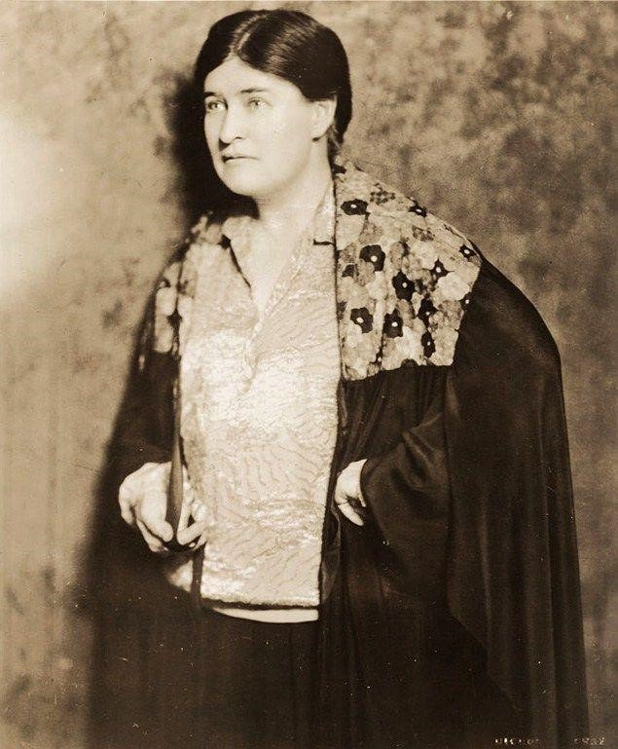

As I looked about me I felt that the grass was the country, as the water is the sea. The red of the grass made all the great prairie the colour of wine-stains, or of certain seaweeds when they are first washed up. And there was so much motion in it; the whole country seemed, somehow, to be running.
— Excerpt from My Ántonia by Willa Cather

Overview
The National Statuary Hall Collection, established by Congress in 1864, houses two statues representing historical figures from each state. Statues of Julius Sterling Morton and William Jennings Bryan currently represent Nebraska, and due to Federal legislation passed in 2000, both are being replaced by Willa Cather and Standing Bear, respectively.
LB807 paved the path for the replacement of the Morton statue with one of Pulitzer Prizewinning author Willa Cather. The Willa Cather National Statuary Hall Selection Committee (Selection Committee) is comprised of members of the Nebraska Hall of Fame commission. The Selection Committee, in consultation with the Nebraska Arts Council, will oversee the selection a sculptor (Artist) for creation and placement of the Willa Cather statue.
The site for the final, over life-size bronze statue is in the U.S. Capitol and National Statuary Hall, upon approval from the Joint Committee on the Library at multiple stages of completion.

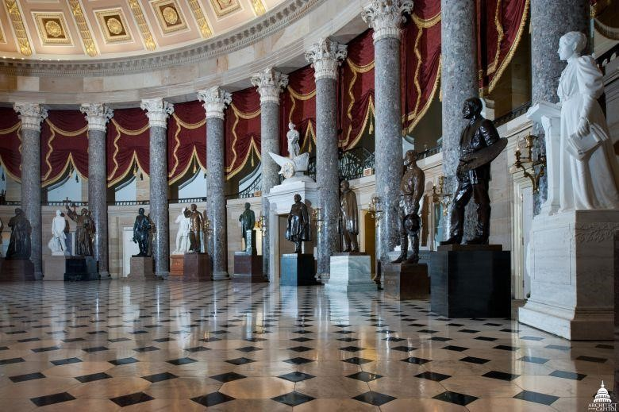
National Statuary Hall

Eligibility
This Request for Qualifications (RFQ) competition is open to all professional artists or artist teams throughout the United States.

Budget

$150,000

Selection Process

The Willa Cather National Statuary Hall Selection Committee, in consultation with the Nebraska Arts Council, has full oversight for the selection and placement of the Willa Cather statue. The committee will review RFQ submissions on SlideRoom. Three to five artists will present proposals in Lincoln, NE. Proposals should include a concept, design, budget and a two-foot maquette. Finalists will receive proposal and travel stipends.

Schedule

The Selection Committee reserves the right to change or extend timeline without notice.

⋅ RFQ Open: Tuesday, October 30, 2018
⋅ RFQ Close: Friday, November 30, 2018
⋅ Committee meeting to select finalists: December 3-7, 2018  Interview of finalists, review proposals: January 3-11, 2018
⋅ Proposal to be approved by Statuary Hall: TBD
⋅ Contract signed and sculpture in progress: TBD
⋅ Installation of artwork: December 2019

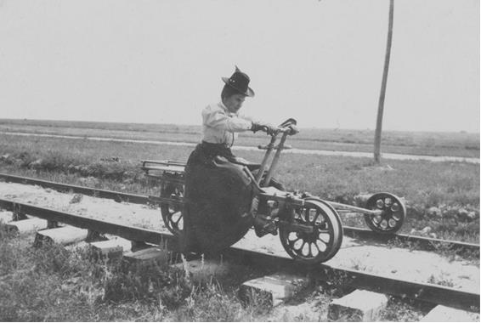
Willa Cather riding a handcar along the railroad in Wyoming in about 1905.

Mission
The goal of the selection committee is to place in the Nation’s capital the best representation of Willa Cather to magnify her successes as a renowned writer of American stories and skillful harnesser of concepts and actions for leading a full, meaningful life.
Artist selection criteria will be based on:
⋅ Artistic Excellence and proven ability to achieve desired outcomes.
⋅ Engaging pose that embodies Willa Cather’s physical and emotive likeness.
⋅ Ability to achieve and describe a creative solution that binds the statue and pedestal to Nebraska and Cather’s literary accomplishments.
⋅ Compatibility of artistic style and requirements within the National Statuary Hall.
Statue Requirements of Architect of the Capitol (AOC)
⋅ Bronze statue, between seven and eight feet, the height with pedestal should not exceed eleven feet. In that size range, the combined weight should not exceed 5,000 pounds.
⋅ Inscriptions, patinas, clothing items, dimensions, weight, etc needs approval by AOC.  Sculpture should not have any protruding or sharp elements.

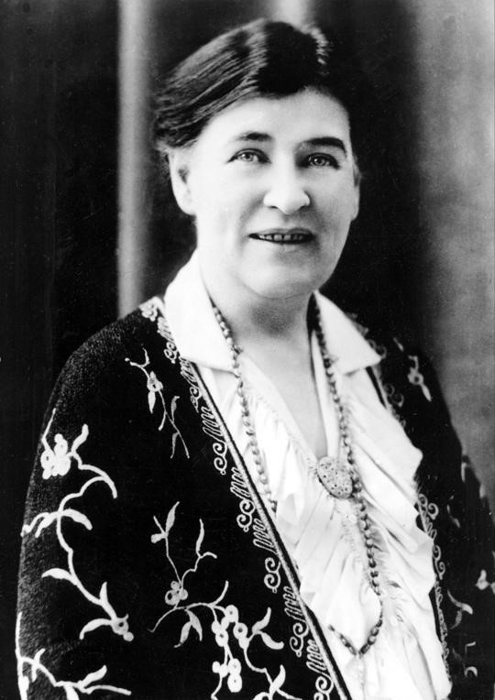

Application Requirements
SlideRoom is the online review system used for the application process; applications received in any format other than SlideRoom will not be considered in the selection process. Submit materials on SlideRoom via this portal: https://nebraska.slideroom.com.
Technical assistance: Access the SlideRoom Help Desk at www.slideroom.com/support.html.

Visual Support Materials
Image descriptions: Include relevant descriptions with each corresponding image on SlideRoom and include project budgets where applicable.
Images – Ten (10) digital images of relevant completed artwork projects. Upload images as jpg files, no larger than 1220px @ 72dpi.
Video - Optional video file may demonstrate moving parts, time-based work, functionality, etc.
Upload as mov, wmv, of flv files, no larger than 60MB each, nor longer than five minutes each.

Required Materials
CV/Resume: Limit to three pages.
Three Professional References: Complete contact information for references with a deep knowledge of your artwork and work methods. Ex: Commissioning organization, architect, etc.
Statement of Interest: How do your personal style and past projects relate to this project. Describe briefly your interest and concept for this project. Use 500 words or less.

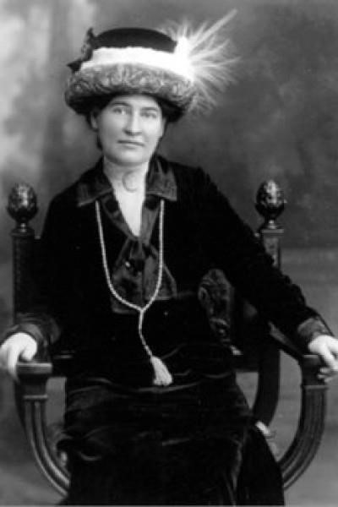

Contact

Meagan Dion, Public Art and Artist Programs Specialist

Nebrask
a Arts Council, 1004 Farnam S
t,
Omaha, NE 68102

402-595-3935, meagan.dion@nebraska.gov

The Willa Cather National Statuary Hall Selection Committee is actively accepting applications to take ownership of the J. Sterling Morton statue currently displayed in Statuary Hall in Washington, DC.
All applications must be received by December 31, 2019.
The Nebraska Legislature approved a measure to replace the Morton statue, which is projected to return to Nebraska sometime in the summer of 2020.
Identified finalists will be asked to present their proposal to the committee prior to a decision during the Willa Cather National Statuary Hall Selection Committee meeting on January 2020.
The J. Sterling Morton statue and pedestal dimensions are as follows:
Statue Material: Bronze
Base Material: Marble
Artist: Rudulph Evans
Created: 1937
Statue Height: 80 3/4”
Statue Width: 32" Statue Depth: 26 3/4" Statue Weight: 1,934 lbs.
Pedestal Material: Lynchburg Marble
Pedestal Height: 36 1/4"
Pedestal Width: 37” Pedestal Depth: 31”
Pedestal Weight: 3,656 lbs.
Total Weight (Statue and Pedestal): 5,590 lbs.
Total Height (Statue and Pedestal): 117"

Please submit the following requested information to History Nebraska, Attention Willa Cather National Statuary Hall Selection Committee:
- Requesting Entity
- Point of Contact Name, Phone Number, Email, website, etc.
- Proposed Statue Location (City and specific location such as a museum or park, etc.)
- Why your proposed location is an appropriate space to display J. Sterling Morton (historical significance, ties to the area, etc.)
- Indoor or Outdoor Location
- Public Access of Proposed Location
- Ability to financially cover the transportation and rigging costs from Washington, DC to the proposed

Classification: Restricted

location. This is not a requirement, but preference will be given to proposals with a financial commitment. (The estimated cost is $5,000.)
- Commitment and plans to financially support the statue. All maintenance, insurance, and upkeep will be the sole responsibility of the selected proposal.
The J. Sterling Morton statue will reside with the selected entity at the proposed location. Ownership will be transferred via a deed of Gift from History Nebraska to the selected organization.
Questions regarding the application process should be directed to:
Trevor Jones
History Nebraska
1500 R Street
Lincoln, NE 68508-1651 403-471-4745 trevor.jones@nebraska.gov

Classification: Restricted

Attachment 3
Artist Selection Process Resource Guide | 2013 by Americans for the Arts

Artist Selection Resource Guide
|
7/11/2013

1

Artist Selection Process Resource Guide
|
2013

WHY art at this site?

WHAT

kind of public art?

PUBLIC ART PROJECT

W
HO makes decisions

HOW do you

select an artist?

WHERE is the art

in the site’s context?

Artist Selection Resource Guide
|
7/11/2013

2

C
ONTENTS

Introduction

2

Who Makes Decisions?

2

Appointing a Selection Committee

4

Selection Committee Responsibilities

4

How Do You Select Artists?

5

Selection Process

Options

5
-
6

Types of Calls for Artists

6

How Do You Write a Call for Artists?

7

Call Elements: Definitions and Descriptions

7
-
11

Getting the Word Out: Where to Advertise

11

What Happens After An Artist is

Selected?

11

Sample Request for Proposals (RFP)

Sample Request for Qualifications (RFQ)

The Public Art Network
:

A Program of Americans for the Arts

Americans for the Arts Public Art Network (PAN) develops professional services for the
multitude

of
individuals and organizations engaged in the diverse field of public art. PAN is the only professional
network in the United States dedicated to advancing public art programs and projects through advocacy,
policy, and information resources to
further art and design in our built environment.

PAN

serves a membership of more than 1,000 public art programs
and

artists nationwide
,

and develops
strategies and tools based on best practices
for

improv
ing

communities through public art.

A
rtists,
communities and organizations
, and art and design professionals
come together
through online resources,
professional development and education opportunities, knowledge
-
sharing practices, and strategic
partnerships. For more information about PAN or America
ns for the Arts, email
pan@artsusa.org

or visit

www.Americansforthearts.org/PA
N

Artist Selection Resource Guide| 7/11/2013 3

INTRODUCTION
Whether your public art program has been writing calls for artists for years or your organization is just getting started with commissioning public art, this Artist Selection Process Resource Guide contains information about best practices that will help you navigate the process. The guide will outline the best ways for your community or organization to develop opportunities that clearly describe your projects that provides applicants with the information they need to evaluate whether they are a good match for your project and community.

WHO MAKES THE DECISIONS?
Before you begin the artist selection process, the first step is to establish how the project will be managed and to identify the required steps for approval. In every case, strong administrative management can ensure that the best artwork is created in a fair, balanced, and properly funded manner. Have in place a mechanism and/or structure for evaluating proposals, making selection decisions and communicating with representatives of the local arts community. Changing the process in midstream can only lead to confusion and lack of trust in the program on the part of the community and the artists whose work you are trying to bring to your community to make it a greater place to live. Remember, standing by the best process can be the best way to weather any controversy that may arise.

Who Reviews and Who Approves?
Many programs have ordinances, policies and procedures in place regarding how a site is selected, how an artist is chosen and who reviews/approves the proposed artwork. New programs need to have a full understanding of how their given governmental or nonprofit support structure works before engaging in an art selection process. Make sure everyone agrees on the final approval process well before starting the selection process. It is recommended that every effort be made to de-politicize the process by limiting involvement of elected officials and curbing the impulse to conduct public polls on the web.

A review by either city staff or an arts council/commission typically includes approval of a conceptual approach and schematic design. Reviews and approvals can be as complex as having all facets of the process be reviewed by city arts staff, public art advisory committees, city manager, city council and mayor. On the other hand, they can also be as simple as a review by city staff to make sure the proposal conforms to a city policy. These oversight responsibilities should be conducted by knowledgeable persons or committee member/s.

Everyone knows that if you ask for an opinion you will be sure to get many. Public opinion does not always ensure good art. Great art is the result of great vision. No matter if a city has a weak public art policy or a strong public art ordinance, the involvement of the public should be limited. Social media has given rise to soliciting opinions from a “public” who may not even know anything about your community and may live in another country or continent. On-line voting initiated by local media does not ensure quality control of the creative process. Too many irons in the fire can lead to “art by committee” with the artist frantically trying to accommodate everyone’s ideas while his/her own get lost in the shuffle.
Artist Selection Resource Guide| 7/11/2013 4

Appointing a Selection Committee
The artist or art work may be selected by an established public art committee; by a board or commission with defined roles; or by an ad hoc review committee that has been put together for the sole purpose of selecting the artist and approving the work. Ideally such a committee should consist of individuals who can candidly educate each other on art, the construction project, site details as well as characterize the community. Participants should be willing to engage in debate and be able to judge their peers objectively. There is an art to appointing members to a selection committee. Personalities, knowledge, role in the construction project or relationship to a community are important things to consider.
Voting members on a selection committee should include arts professionals, the project's building and/or landscape architect or engineer, a representative of the participating city/county/state bureau, and at least one citizen at large who represents the community where the project is located. It is recommended that the public art staff and project manager from the public bureau be non-voting members. A conflict of interest policy should be required to participate.

Each committee member serves through the completion of one public art project. For complex projects, a sub-committee may be appointed to make recommendations to the full committee. At least two of those sub-committee members must be artists.

Selection Committee Responsibilities
Clarify the role of the Selection Committee with the “powers that be” before starting the process. Will the committee have the final say on who is selected? Do they approve the final design or is their job completed once the artist is selected? Typically committees approve all selections by a majority vote or consensus; yet there are instances where scoring may be required.

Assigned committee responsibilities can vary depending upon how a particular jurisdiction operates. For example, while project goals, sites and suitable art forms can often be determined prior to the convening of the selection committee, some programs opt to assign these responsibilities to an appointed selection committee. Other tasks can include developing the project's goals, sites for artwork, and suitable art forms.

A committee should always reserve the option to make no selection from submitted applications and to reopen the competition or propose other methods of selection if no proposal is accepted. This is something that can be stated in the Call for Artists.

HOW DO YOU SELECT ARTISTS?
Artist Selection Resource Guide| 7/11/2013 5

No single selection process is the best for every public art commission. Geography, demographics and a municipality’s culture all play significant roles. Many established programs have developed processes well-refined over time based on experience as well as feedback from artists.

Public art programs and organizations commissioning public art projects can enlist artists to be considered in a variety of ways. These include calls for artists, juried slide registries, and direct invitations. Online calls for artists have grown in use over the past few years and represent a significant cost time savings for both artists and organizations.

There are thousands of artists interested in creating art for public spaces. A list of on-line resources is listed at the end of this guide. Many municipal or state agencies have pre-qualified artist rosters. juried in by arts professionals, that include artists with demonstrated capabilities and a strong esthetic and that may be available to view on-line. At the end of this guide, there is a list of where you can advertise a public art opportunity. There are also many curators, public art administrators and local arts agencies employees who have a vast knowledge of artists and their work.

Selection Process Options
Selection processes include open or limited competitions, invitationals, or direct selection. An open competition is broadly promoted (either regionally, nationally or internationally) to encourage numerous applicants. A limited competition is directed to a specific group of artists, sometimes narrowed by discipline, often by geographic location (only the state of...) On occasion the size of the project budget for art dictates limiting the reach of a call and the selection process to direct purchase.

Invitational. The art experts on your Selection Committee as well as the public art manager can draw up a short list of artists to interview for a project. Depending on the budget and scope of a project, interviews should be preceded by a site tour and the artists need to be given or referred to any relevant materials associated with the building site or arrange a group meeting with the design team so that the artists have a general understanding of the opportunities and limitations for a particular site. During the interviews, the artists should be asked to share images of past work, discuss their creative process and how they might approach this particular opportunity. This model, when occurring while the project is still in design, allows the selected artist an opportunity to work with the design team, agencies and community to develop a work that responds to the specific criteria of the site and building program.

Limited Invitational. Invite three to five artists to present a conceptual proposal and pay them a stipend. Site tours and relevant printed materials should be shared with the finalist. Costs for travel and lodging should also be covered. Most artists do not have a large firm that supports them as do most architects. This model is often used when a committee or agency would prefer more visual information about how an artist might approach a site. Following the selection of an artist using this process, there would be a design phase contract issued in which the artist would continue to work with the client to fine-tune the proposal. Do not expect to get details regarding engineering, construction
Artist Selection Resource Guide| 7/11/2013 6

or fabrication methods at this point in the process. A committee should approach the conceptual proposal option with an open mind since during the design phase, many things can change.

Direct Selection. In this model, an artist is invited to do a project by the selection committee/developer/ curator/visionary/benefactor/mayor, etc. This is the simplest method yet it depends upon the knowledge and ability of the person selecting the art work to make an informed decision for the community at large.

Types of Calls for Artists
There are two traditional types of Calls for Artists: Requests for Qualifications (RFQ) and Requests for Proposals (RFP). Current best practices supported by PAN endorse payment to the artist for any creative work related to the development of a concept. An RFP specifically and routinely incorporates a fee for the artist in addition to the reimbursement of travel expenses. There has been discussion within the field of public art about the appropriateness of RFPs versus RFQs, including the possibility that a Call for Artists may include a request for brief comment (rather than a full proposal) on the artist’s approach to the project.

A Request for Qualifications (RFQ) invites artists to send their qualifications to be reviewed by the selection committee, but does not require a specific proposal to be submitted. RFQs are used to choose artists based on their past and current art and achievements. Often, a statement of interest that addresses the goals of the project is requested. This can be a complicated, costly and prolonged process, but a wide range of artistic styles can be viewed and a committee has the ability to discuss the merits as it applies to the project.

Selection committees using a Request for Proposals (RFP) willingly spend proposal funds upfront to be able to review a small number of proposals prior to selecting an artist to work on a project from design development through installation and dedication. It is strongly recommended that programs not ask for concepts or proposals as part of the general application. This places the artist in the unfair situation of having to submit an idea based on little background except perhaps what can be gleaned from the RFQ and the internet (e.g., photograph of the site).

PAN does not recommend issuing an RFP in which artists are asked to produce drawings/ideas based on limited information. Many talented and successful artists refuse to be involved in such competitions. Creating ideas is the “currency” of artists, giving away ideas for free is not fiscally responsible.

Artist Selection Resource Guide| 7/11/2013 7

HOW DO YOU WRITE A CALL FOR ARTISTS?
A Call for Artists is an opportunity notice that gives artists the necessary information about a project in order to apply. The site description, budget, timeline, eligibility guidelines and public art goals are some of the basic requirements to be included in any Call for Artists/RFQ. Issuing a Call for Artists is a standard practice in the public art field. There are currently over 350 public art programs in the United States can be found in both rural and urban areas; in federal, state, county and city government agencies; or private nonprofit or for-profit organizations run independently or as part of a local arts agency.

All versions of Calls for Artists can take place online to alleviate the processing of multiple (sometimes hundreds) of submission materials. Currently (in 2013), there are three on-line options (callforentry.org, slideroom.com, and publicartist.org) with many programs opting to create their own on-line application system. These options are changing rapidly and it is best to conduct on-line research regarding the best choice for your program.

Call Elements: Definitions & Descriptions
Once you’ve decided to write a Call for Artists, there are essential pieces of information that should be included. Below is a reference list that includes advice on how to clearly convey your information.

Call Summary
A brief project summary. The Call Summary helps artists quickly decide whether they are interested or eligible for the call and lets organizations posting the call decide how it should be promoted. Include the project name, commissioning organization, application deadline, project timeline, budget, geographic eligibility requirements, and whether it is an RFQ or RFP.

Project Description
An overview of the artist’s scope of services. Describe whether it is a design-team project, commission for new work, integrated art, functional art replacing functional items, master plan, artist residency, purchase of existing art, or other type of opportunity. Include a description of the organization overseeing the project.

Art Goals or Criteria
A list of any predetermined objectives for the art established by the commissioning organization, funder, or community. The specificity of the objectives will vary by commissioning organization and reflects the characteristics of each project. The list can be broad – e.g., create a sense of place within the community – or specific – e.g., design streetscape elements that reflect the industrial history of the neighborhood.

Site or Art Location Plans
Site plans, maps, photographs, or other visual information of the site or art location. Describe the site’s function; include what activities will happen there and who uses it. Be sure to include whether or not the site is open to the public, or if the public can see but not enter the site. Include a description or history of the site and community where the art will be and list additional resources for the artist to research.

Artist Selection Resource Guide| 7/11/2013 8

Often a site for the art is determined prior to selecting an artist. Site is determined by the administrator or public art committee along with the design team in consultation with city staff. An alternative approach is to select an artist and let them be part of the decision about the best site.

Art Location Description
A description of where the art will be within the project site. Sometimes the location for art is predetermined by the funder, commissioning organization, or community before a Call for Artists is distributed. If this applies to your project, provide a highly detailed description of where the art will be located within the site, especially for an RFP. The description should include, but not be limited to: Engineering and architectural information about the location’s structure, materials used at the location, visibility within the site, and lighting information. If the art location is not predetermined, state whether or not the artist will be free to participate in selecting the art site.

Budget
The amount of funding allocated to art for the project. Clearly state the budget for art and what is expected to be covered (not all projects have the same expectations of project costs covered by the art budget). For instance, in a design-team project, the budget may include only the costs of artists’ fees and travel. In the commissioning of art, project costs may include the artist’s fee, travel, engineering, materials, fabrication, transportation, documentation, and oversight of installation but not actual installation costs.

Often costs for insurance, taxes, studio overhead, and miscellaneous items are not included in an artist’s budget by the artist or commissioning agency. It should be clear from the beginning which costs may legitimately be included in the artist’s budget and which are covered by others. Finally, in some cases an actual art project budget has not been set at the time an artist is selected. It is important to determine the amount that is secured for the project and the art and what has to be raised to realize each.

Artist Eligibility
The qualifications that an artist must meet in order to be eligible for a project. Questions to consider include:
- Must the artist live/work in a certain geographic area or is the call open to artists nationally?
- Is the call only open to professional artists or are students eligible?
- Are artist teams eligible for the project?
- Must the artist have completed a project with a similar budget, scale, and scope?

If you are seeking to reach out to certain types of artists, include a sentence encouraging artists that meet those objectives to apply. For example, if the commissioning organization is seeking to reach out to emerging artists, include a statement such as “professional artists who are new to the field of public art are encouraged to apply.” Or if the project is one that will involve a high level of community interaction in a specific setting, include a statement such as “artists who have experience interacting with community are encouraged to apply.”

This is also the place to include an equal opportunity statement that may be required by the commissioning organization, local municipality, funder, or owner.

Application Requirements
The list of materials artists should send by mail or online with their applications. Be very specific about the information artists should include with their application since it determines how it is
Artist Selection Resource Guide| 7/11/2013 9

presented to the panel reviewing applicants and selecting artists. Typical application requirements include:
- Visual support materials
- Annotated lists
- Statement of interest, often restricted to a number of words (e.g. 200 words)
- Resume or short biography
- Self-addressed stamped envelope (SASE) for the return of hardcopy materials
- Project proposal (for RFPs)

Visual support materials can include digital images in specific formats, slides, videos, CDs, and prints or photocopies. If requesting digital images , list the number of images artists may submit and how they should be labeled. If a panel is reviewing digital images, CDs or video, in addition to the number of images be specific about length of time for moving images and the formats the panel will be capable of viewing. Identify the number of copies of support materials the artist is to include.
Examples:
  - For visual art, up to a total of 10 images of past work on a CD. All images must be in JPEG format (.jpg), and 1024 pixels (14.222 inches) on the longest side, formatted at 72 dpi. Each image filename must be named as follows: artist’s last name, first initial, underscore, and number corresponding to the number on the image list (e.g. smithp_01.jpg). No personal websites will be reviewed. If using a Mac, be sure to use the appropriate Windows filename extension (e.g.:
"smithp_01.jpg" rather than "smithj_01")

  - For performance or media art, video documentation formatted on a DVD as a
Windows Media Player or QuickTime file CD/DVD can contain up to 3 video sampleswithout an auto start menu, with a total running time of no more . Each than 10 minutes for all samples collectively.

  - For media art, audio documentation must be formatted on a CD/CD-R containing up to 5 audio samples, with a total running time of no more than 10 minutes for all samples collectively.

The annotated image list allows the artist to describe the visual support material and usually includes: description, material, location, budget, client or commissioning organization, and any other relevant project information.The statement of interest allows artists to introduce themselves and describe their specific interest in a project, their potential approach to the project or creating public art, answer any specific questions presented in the RFQ and describe any past relevant experience.

If artist teams may apply, clearly state if you require additional visual support materials, resume, and references for each team member. If you are inviting and paying artists to develop proposals, clearly list the types of submission materials you would like the artist to submit to best present their work to the review panel. Typical proposal submission materials include: project description, drawings, renderings, model, photographs, materials list, budget, timeline, references, fabrication, installation, and maintenance information.

Artist Selection Resource Guide| 7/11/2013 10

Deadline
The date when an application must be either received or postmarked. List the date by which an application must be either received at the mailing or online address or postmarked. Be sure to state if overnight or express delivery is NOT permitted.

Submission Address
The address to which application is submitted or mailed. Include the online address or mailing address. If overnight or express shipping is allowed, be sure that the address is not a post office box. Supply an alternate address for this type of delivery. If only online submissions are acceptable, clearly state thatthere will be no mailed submissions accepted.

Selection Process
A description of how the applications will be reviewed and an artist selected. Include the types of people who are on the selection panel, e.g., art and design professionals, community
representatives, agency representatives, and funders. Include the number, or range, of finalists that will be selected and what will be required of the finalists, including interviews, proposals, dates for presentations, and travel. Typically, there are three finalists, but no more than five. If finalists are subject to interview, state if a fee and travel expenses are covered as well as timeline for interviews and who will participate in the interview process and make the final artist selection.

If proposals are required, provide artists with information about what is included in a proposal, timeline, budget, etc., and fee for proposal, travel, and presentation, and decision-making schedule.

Selection Criteria
A list of the criteria established by the commissioning agency or artist selection panel that will guide the evaluation of applications. Listing the selection criteria establishes the priorities of the artist selection panel. The list also assists artists when considering whether they should apply for a project. For example, if the criteria for the RFQ includes artistic excellence, evidence of working in the field of public art for more than five years, and experience working in community settings, artists new to public art will be informed that their qualifications are not a good fit for the project.

Project Timeline
The timeline the project will follow from artist selection to project completion. The timeline includes dates for the following milestones, as they apply: Submission deadline, panel review, finalist notification, interview schedule, proposal presentations, final artist selection, contract, design review phases, fabrication and installation schedule for art coordinated with project construction, and completion date.

Sources for Additional Information
A list of resources the artist may consult for additional project information on the project, site, commissioning organization, community, area history, etc. Providing artists a list of resources they can consult about different aspects of the project can help them decide if they want to apply and if their work is a good fit with the project parameters. In the case of an RFP, the list can be a launching point for research. Include website addresses, publications, contact information for organizations, and other information that would be helpful and relevant to artists as they research the project.

Artist Selection Resource Guide
|
7/11/2013

11

Resources for Questions

The contact
information for the person or organization to be called if the artist has questions or
needs additional information. Be clear about whether telephone calls or email inquiries are accepted
or if questions may only be submitted by fax or email. Also state if

there is

a deadline by which
questions must be submitted.

WHAT HAPPENS

AFTER AN ARTIST IS SELECTED?

Proposal Contracts/Design Phase Contracts

Before an artist or artists begin their research to develop a proposal or proposals
–

their ideas
–

they are

placed under contract and paid to work on the project. Organizations use RFPs when they choose to work
with a small pool of artists, or a single artist, based on their qualifications, to develop a detailed proposal

for the site or project based on limited

exposure to the project. An RFP does not guarantee the artist(s)
will be selected to implement their ideas or proposed art but PAN advocates that

each artist is paid a
stipend and travel expenses for proposal development and presentation, beyond a request

for a brief
comment on the artist’s initial thoughts on an approach to the commission. Some governmental
regulations require the solicitation of proposals for selection, and prior to contracting, for implementation
of a proposal.

GETTING THE WORD OUT: WHERE TO PROMOTE YOUR CALL FOR ARTISTS

Public Art Network Listserv

Available to
members of
Americans for the Arts/PAN, this networking tool connects colleagues and acts
as a research engine, newsletter, and stage for cr
itical dialo
gue. Artist

opportunities are frequently posted
on the listserv as well as in the PAN e
-
mail broadcast. To join, visit:
www.Americansforthearts/PA
N

or e
-
mail
membe
rship@artsusa.org

.

To submit information for the PAN Weekly, e
-
mail
pan@artsusa.org
.

Artists Register

https://artistsregister.com
/
o
pportunities

CaFÉ

http://www.callforentry.org

Public Art Programs that maintain lists of
national/international
opportunities
:

4
Culture

(
Seattle/King County
)

http://www.4culture.org/

City of Las Vegas Arts Commission

t
http://www.lvartscommission.com/artis
-
opportunities
/

City of Phoenix

http://phoenix.gov/arts/publicart/callstoart/natl
o
pps
/

Artist Selection Resource Guide
|
7/11/2013

12

Questions to ask before starting a project

(
from LK
)

•

Where does public art fit into the local governmental structure?

Is it administered through
Arts and Culture, Parks and Recreation, Economic Development? Wherever it’s housed, how
does that affect the process? Is there an appointed Arts Commission or an established cultural
council? What are their responsibilities?

•

What is the approval process for your municipality?

Who signs contracts and makes
payments? Who appoints selection committees? Who approves proposals? Have you ever
negotiated a contract with an artist? If not, identify resources to consult on best p
ractices for
contracting an artist to design, fabricate and install an artwork.

•

Has the community ever placed, or supervised the installation of public art?

•

Who will maintain the art
? Is there a maintenance plan? Has an art conservator reviewed the
des
ign?

•

Do you know who the artists are who live and work in this community?

How do you
advertise your public art opportunities?

Attachment 4
Engineering Guidelines for Pedestal Design

Engineering Guidelines for the National Statuary Hall Collection

Overall weight recommendation
There are widely different structural floor capacities in the various locations available for statue placement; therefore, a rigid recommendation for overall weight is nearly impossible to define. A general rule of thumb to assure the ability to place the statue at almost any location would be restrict the overall total weight of statue + pedestal to no more than 4,500 lbs. and have a minimum pedestal base footprint of 40” x 40”. The Architect of the Capitol (AOC) realizes that this may overly restrict the selection of statue medium and pedestal construction and recognizes that there are some areas that do have the ability to support a statue that exceeds the above recommendations. If, during the planning phases, the state anticipates that a statue + pedestal might exceed the criteria, the AOC recommends that the state contact the curator’s office to determine if the proposed location of the installation has sufficient structural capacity. Supply the anticipated maximum weight and proposed base footprint during the conversation with the curator. States are cautioned not to proceed too far through design until the AOC confirms that structural capacity is available.
The majority of travel paths to reach the installation locations have some overall size restrictions. Based on past installations the designer should plan for the statue and the pedestal to be separate pieces, to be delivered to the final installation location and assembled in place. If separating the statue and pedestal will overly restrict the artistic vision, consult the curator for additional direction.
Depending on the final installation location there may also be weight restrictions along the travel path. The installer should consult with the curator regarding the travel path through the building(s), submit the means and methods of transport including maximum wheel loads and wheel spacing, and submit rigging plans for erecting the statue and pedestal.

Dimensions
When you submit the engineering documentation required with step 6 of Procedure and Guidelines for Replacement of Statues in the National Statuary Hall Collection, include the anticipated weight and dimensions of the statue and pedestal with the documentation, in an email, or in an attached document. These include:
- Statue o Height, width, and depth (at longest measurement for each) o Weight
- Pedestal o Height, width, and depth of fabricated pedestal o Weight of fabricated pedestal
- Total height and weight of pedestal and statue together
When you submit materials to support approval of the completed statue, include the actual dimensions and final weight of the statue and pedestal.

Structural stability requirements
The statue and pedestal shall be of sufficient construction to not pose a risk to any building occupants. This includes a stability check with calculations, signed and sealed by a professional engineer, as part of the approval process.
The stability check shall utilize ASCE 7 load combinations for the following non-concurrent load cases:
- 350 lbs. in any horizontal direction applied at the top of the pedestal (live load).
- 200 lbs. in any direction applied at the mid-height of the statue (live load).
- 75 lbs. in any direction applied at the top of the statue (live load).
- Seismic Design Horizontal and Vertical Forces for Nonstructural Components (ASCE 7) applied at the center of gravity of the statue, with the following constants: a. a_{p} = 2 ½
  - S_{DS} = 0.160
  - I_{p} = 1.0
  - R_{p} = 2 ½
  - h = 70 ft.
  - z : CVC = 0 ft. ; USC 1st Floor = 6 ft. ; USC 2nd Floor = 25 ft.
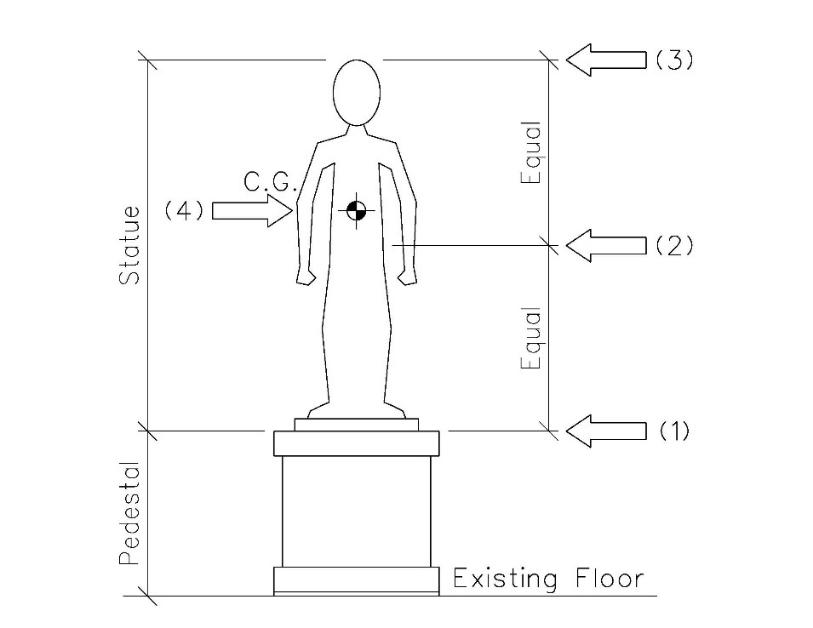
There is no requirement for the statue be anchored to the pedestal, provided that the stability of a non-anchored interface can be proven through calculation. Any anchorage shall meet the above load cases.
The existing floors are historic; anchorage of the pedestal to the base building floor is not permissible. The stability of a non-anchored pedestal shall be proven in the calculations for the Code load combinations.

Pedestal Structural Construction and Detailing
Pedestals shall have sufficient strength to support the weight of the statue and the design lateral load (noted above). To minimize weight, AOC recommends a hollow pedestal with an internal steel frame faced in stone, which must be designed by a professional engineer. For the final design, the state must submit a pedestal shop drawing, signed and sealed by a professional engineer, as part of the approval process to ensure that the pedestal meets safety requirements. The professional engineer’s calculations and sketches shall be coordinated and in agreement with the fabricator’s pedestal shop drawings.
The historic floors below the pedestal must be protected from damage. Stone or metal may not be placed directly on the existing floors. Non-staining bearing pads, such a Neoprene or similar material, shall be provided between the interface of the pedestal and floor and shall only occur below the pedestal, i.e. not be visible in the final condition.
Note that many of the historic floors are not level. Provisions shall be included in the pedestal shop drawing for the field correction of existing floor levelness. Any leveling correction method shall consider a means to distribute loads over a sufficient area to prevent large load concentrations, subject to engineering considerations (submitted by the professional engineer as part of the pedestal structural approval).
Designers have various means to accomplish this leveling, such as steel shim plates and adjustable levelers on bearing plates. An example of an unacceptable means would be small, 1” diameter leveling feet only at the pedestal corners, directly bearing on the existing stone flooring. The concentrated load below this small area would be significant and may result in floor damage. Many previous installations have opted for a continuous steel bearing plate over neoprene bearing pad below the full pedestal footprint, with leveling feet between pedestal and bearing plate. Note that this arrangement is not a requirement, merely an illustration of a previously-used means to accomplish the goal.

