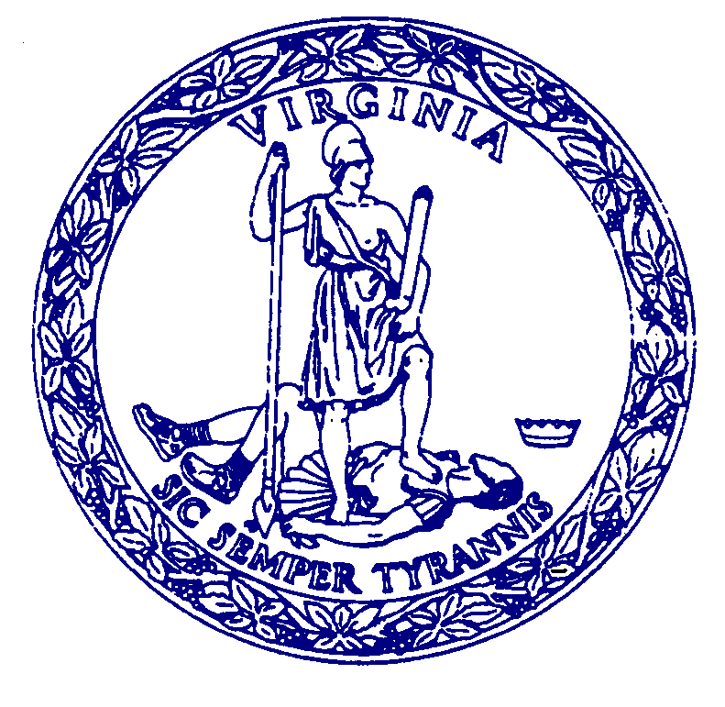
DRAFT AGENDA

MEETING

COMMISSION FOR HISTORICAL STATUES IN THE UNITED STATES CAPITOL

10:00 a.m.
January 4, 2023

Virginia Museum of History & Culture
Reynolds Leadership Center – 2nd Floor
428 N. Arthur Ashe Boulevard, Richmond

Call to Order…………………………………………………..……Senator Louise Lucas, Chair

Roll Call Attendance…………………………………………………….……Stephanie Williams

Approval of Meeting Agenda

Approval of July 21, 2022 Meeting Minutes

Public Comment………………………………………………………………..Stephanie Williams

Introduction of Selected Sculptor…………………………………………………..…Julie Langan

Work Session Between Sculptor and Commission Members..……………………………....DHR

Next Steps………………………………………………………………………………..Julie Langan

Adjourn

