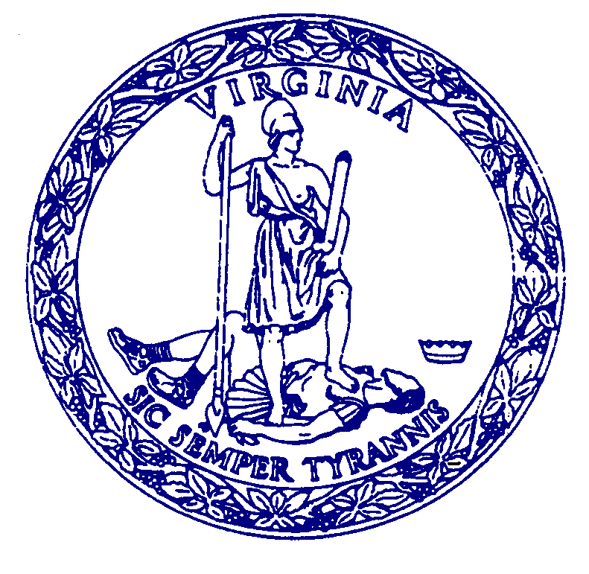
AGENDA

MEETING
of the

COMMISSION FOR HISTORICAL STATUES IN THE UNITED STATES CAPITOL

1:00 p.m.
March 30, 2023

VIRTUAL MEETING

Call to Order………………………………………..……Senator Louise Lucas, Chair

Roll Call Attendance……………..………………………….……Stephanie Williams

Approval of Meeting Agenda

Approval of January 4, 2023 Meeting Minutes

Public Comment…………………………………………………..Stephanie Williams

Presentation of Maquette …….……………..…..…Julie Langan &Steven Weitzman

Next Steps……………….………………………………………………...Julie Langan

Adjourn

