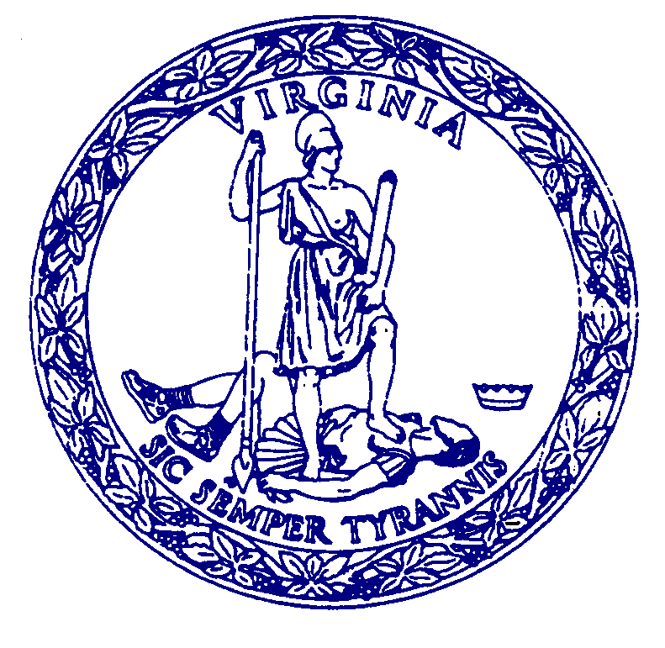
AGENDA

MEETING
of the

COMMISSION FOR HISTORICAL STATUES IN THE UNITED STATES CAPITOL

9:00 a.m.
Saturday, February 24, 2024

VIRTUAL MEETING

Call to Order………………………………………..……Senator Louise Lucas, Chair

Roll Call Attendance……………..………………………….……Stephanie Williams

Approval of Meeting Agenda

Approval of March 30, 2023 Meeting Minutes

Public Comment…………………………………………………..Stephanie Williams

Presentation of Full Scale Model ………………….……………..…..…Julie Langan

Next Steps……………….………………………………………………...Julie Langan

Adjourn

